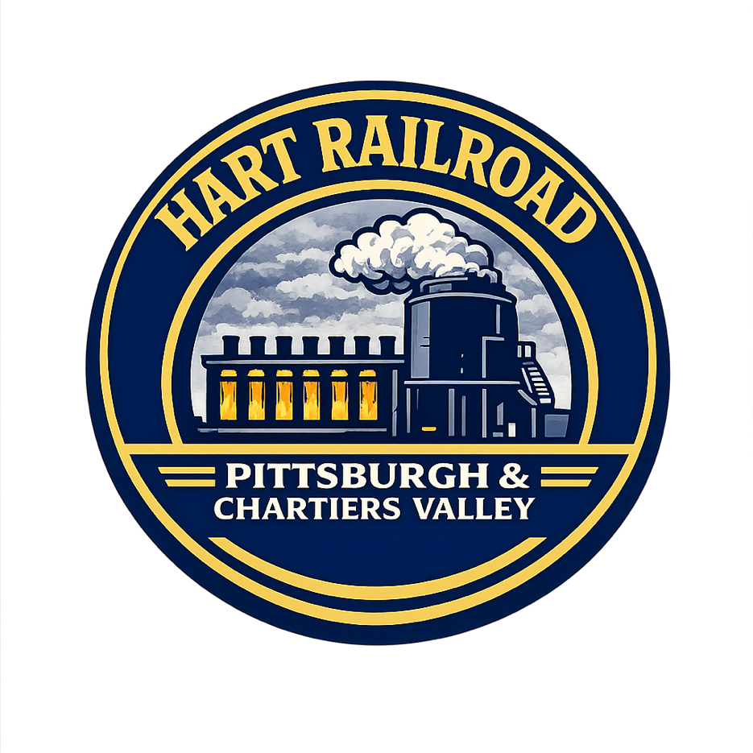

HART Railroad
Pittsburgh & Chartiers Valley Division

Scale Operating Instructions · Revision D
Neville Island Operations
Issuing Authority: Office of the Superintendent
Publication EQ-01
Effective 15 July 1999
Revision D
Official Publication

SECTION 1 — GENERAL RULES
The scale is used to verify and log proper loading of outbound cars prior to departure from South Yard.

1.1 Pre-Scale Alignment & Approach
- Bring the train to a complete stop well before the scale approach track.
- Ensure all handbrakes are fully released and train air is completely cut in.

1.2 Slack Management (Coupled Tension)
- Begin the move by gently stretching out the entire string of cars.
- The train must be 100% fully stretched (in draft) before the first car reaches the scale track.
- Maintain this constant tension throughout the entire weigh run.

1.3 Speed & Braking
- Maintain a strict, uniform speed between 3 and 5 MPH.
- Avoid throttle adjustments, rapid acceleration, or drifting while cars are on the scale.
- Do not use independent, dynamic, or automatic brakes during weighing.
- All scale movements must be performed at restricted speed.

1.4 Safety & Operating Notes
- Never leave the Track Scale Terminal unattended while a car is under weigh.
- Protect shove movements at all times.
- Report scale failures or abnormal readings immediately.

SECTION 2 — SCALE CALIBRATION PROCEDURE

2.1 Preparing the Scale
- Verify the scale is completely clear.
- Open the Track Scale Terminal and select Calibrate mode.

2.2 Calibration Procedure
- Place the Scale Test Car on the LEFT sensor position and weigh the car.
- Adjust the LEFT sensor until Error reads 0.00 tons, then lock the sensor.
- Repeat for the CENTER and RIGHT sensor positions.
- When all three sensors show zero error and the terminal indicates READY, select Save calibration.

2.3 Returning the Scale to Service
- Clear the scale and return the Track Scale Terminal to Weigh mode.
- Return the Scale Test Car to South Yard.

SECTION 3 — WEIGHING OUTBOUND CARS

3.1 Preparing for Weighing
- Open the Track Scale Terminal and select Weigh mode.
- Observe Section 1 movement rules, then spot the car on the scale.
- Select the car from Cars at Scale / Inbound Train.

3.2 Track Scale Display
The terminal displays Adjusted Gross Weight and Net Load for the car on the scale.
- PASS — Record the certified net weight. The car is within prescribed tolerance and approved for outbound movement.
- REJECTED — Overload or left/right imbalance beyond prescribed tolerance; do not release the car.
- Assign a reload order for return to the originating industry.
- Rejected cars must not depart South Yard until reweighed and approved.

